**Questions Based on the RCSB PDB Molecule of the Month**

Go to the Molecule of the Month Article at the RCSB PPDB or PDB-101 websites ([www.rcsb.org](http://www.rcsb.org) or [www.rcsb.org/pdb-101/](http://www.rcsb.org/pdb-101/) respectively). Read the article and respond to the following questions. \**If there are 3 or more different proteins discussed in the article—e.g. as in the case of the Glycolytic Enzymes—choose any one of the molecules to answer the starred (*) questions.*

1. Which Molecule of the Month article did you read?

Piezo1 Mechanosensitive Channel

1. About the Featured Molecule(s)
   1. *Function*: What is the main biological function discussed in the article?

Piezo1 is found in non-sensory tissues, where it helps cells sense local changes in fluid pressure.

* 1. \**Players*: Name the key molecule(s) (proteins, nucleic acid, etc.) performing the function(s) listed above? Are there any other molecules mentioned in the article that interact with the molecule being studied – either facilitating or regulating the discussed function? Name the molecule(s).

Changes in the tension of membranes cause these Piezo proteins to open up and allow positively-charged ions like calcium to enter the cell. This change in ion concentration triggers the sensory response of the cell.

three more detailed structures have just been released (PDB entries 6b3r, 6bpz, 5z10)

These mutant channels are more active than usual and allow excess calcium to enter red blood cells. This has a domino effect on other channels and ultimately leads to dehydration of the cell. Normally this would be a problem, but in areas of the world plagued with malaria, the mutation is very common because the dehydrated cells are resistant to the malaria parasite.

* 1. *Big picture*: Describe in 3-4 sentences how reading this article helps you understand the function of a living organism or the world around you?

By reading this article, I have known that even a single cell has its own way to detect the slight environmental changes through different proteins and afterwards it can give feedback to these changes to maintain the inner equilibrium or to generate a special signal. Cell is a extremely complex machine functioning perfectly with the ability of self-consistence. The way how a cell manages to get the outer information is quite affording for thought.

1. *Explore the structure-function relationship of the molecule(s) discussed in the article
   1. *Overview*: Describe how the shape, size and interaction of relevant molecules discussed in the article help in performing the function

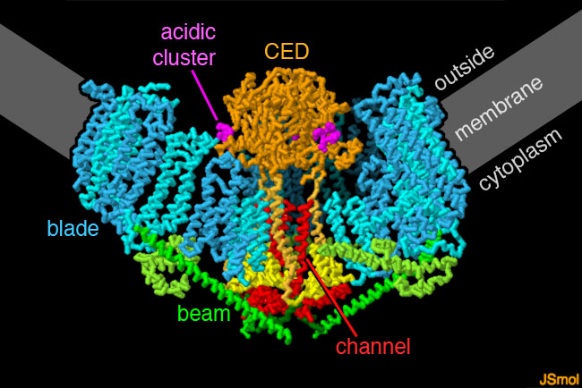

The blades (blue) are composed of a series of similar domains that are embedded in the membrane.

The blades are not flat, but instead bend the membrane into a cup shape.

A cluster of acidic amino acids (magenta) in the CED domain (orange) is though to help manage access of calcium ions to the central channel, which is surrounded by three helices (red).

A beam (green) connects the blades and the channel, presumably linking changes in the shapes of the blades to opening of the channel.

* 1. *Details*: Go to “Exploring the Structure” section in the article and analyze the structures shown in detail.
     1. *Basic level*: Examine the static images, and JSmol interactive views, where available. If only static images are available, take a screen shot of the image, include it in your answer and explain in 1-2 sentences the structural and functional detail highlighted in it. In articles where the JSmol interactive views are available, take screenshots of at least two different views, and include them in your answer. Explain in 1-2 sentences the structural and functional details that these images highlight.

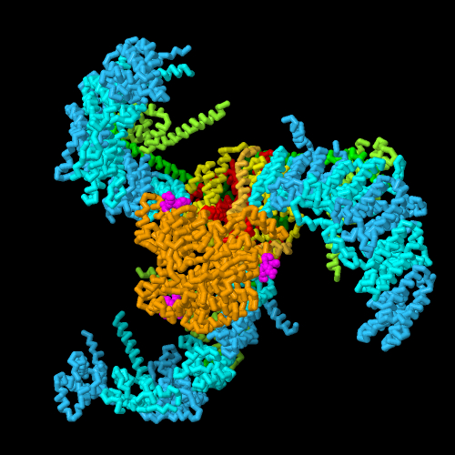

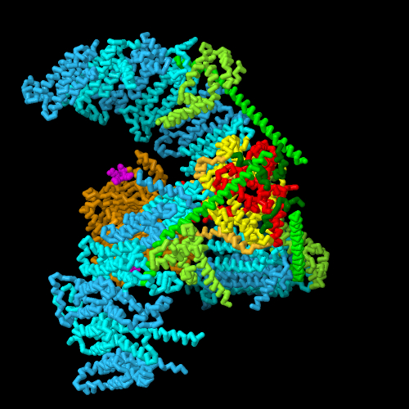

Piezo1, with the blades in blue, CED domain in orange with the acidic cluster in magenta, the long alpha-helical beam in green, and the ion channel in red.(cartoon image)

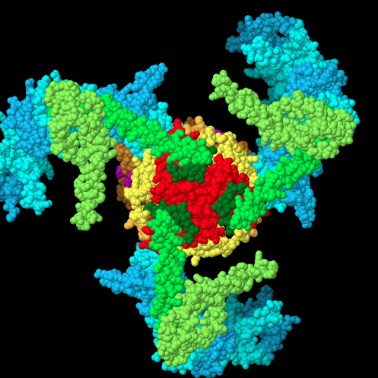

(show atoms mode)

* + 1. *Advanced level*: Click on any one of the 4-character accession code (PDB ID) discussed in the “Exploring the Structure” section of the article. This should lead you to the Structure Summary page of that PDB structure. Click on the “3D View” tab and open a JSmol image that can be manipulated. Select from the various visualization/customization options available. Take screenshots of at least two different views highlighting structural details that are important for its function, and include them in your answer. Include the PDB ID that you use, in your answer. Explain in 1-2 sentences the structural and functional details that each of these images highlight.

5Z10 Structure of the mechanosensitive Piezo1 channel

The mechanosensitive Piezo channels function as key eukaryotic mechanotransducers. The researchers provided this picture with PDB ID 5Z10, where they determine three-bladed, propeller-like electron cryo-microscopy structure of mouse Piezo1 and functionally reveal its mechanotransduction components.

(subunits colored)

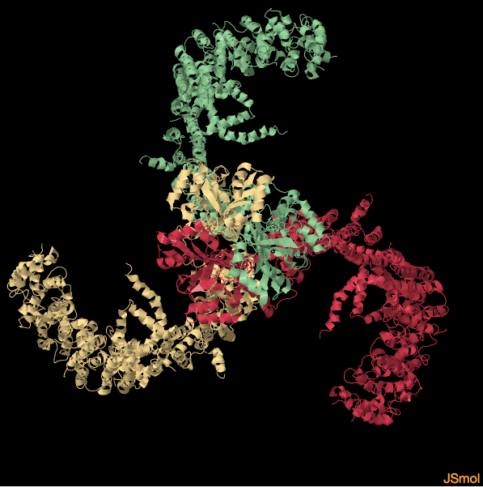

Despite the lack of sequence repetition, we can identify nine repetitive units consisting of four transmembrane helices(pink) each-which we term transmembrane helical units (THUs)-which assemble into a highly curved blade-like structure.

(2D structures – helices, B sheets and loops colored)

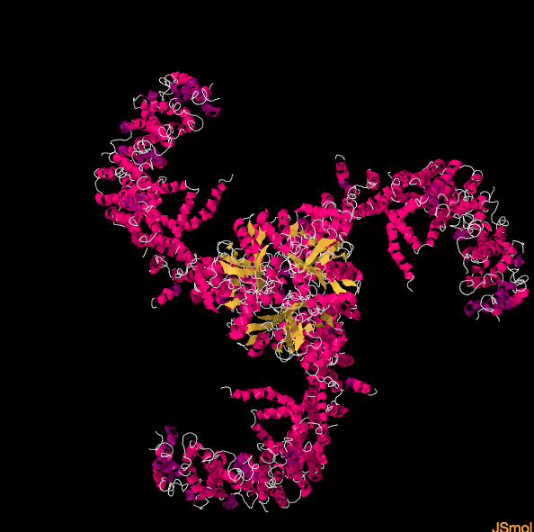

The last transmembrane helix encloses a hydrophobic pore, followed by three intracellular fenestration sites and side portals that contain pore-property-determining residues.

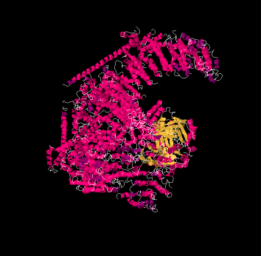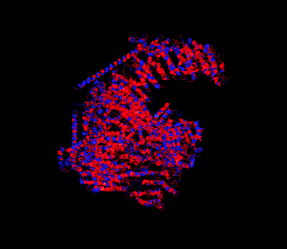 (colored by hodrophobility)

The central region forms a 90 A-long intracellular beam-like structure, which undergoes a lever-like motion to connect THUs to the pore via the interfaces of the C-terminal domain, the anchor-resembling domain and the outer helix. Deleting extracellular loops in the distal THUs or mutating single residues in the beam impairs the mechanical activation of Piezo1. Overall, Piezo1 possesses a unique 38-transmembrane-helix topology and designated mechanotransduction components, which enable a lever-like mechanogating mechanism.

